Week 5: Model Evaluation and Reporting Strategy
Agribusiness Data Analysis Internship
Project: Agricultural Crop Yield Forecasting using FAOSTAT data

1. Executive Summary
I compared a median baseline with three machine-learning models. Random Forest was selected because it had the lowest MAE on the validation data.
The final check covers 2012 to 2024 and includes 1,079 crop-year records. On this test period, the model recorded an MAE of 654.59 kg/ha and an RMSE of 1,991.75 kg/ha. Its R-squared was 0.97 and its MAPE was 8.43%.
On the validation data, Random Forest's MAE was 90.46% lower than the median baseline. The test results are encouraging, but the gap between MAE and RMSE shows that a small number of predictions have much larger errors. Those cases should be checked before the model is used for planning.
This test is a rolling one-year-ahead style evaluation: when predicting a later test year, the model can use actual yield records from earlier years, as they would become available over time. It does not test a single forecast made for all future years at once. The model should also be checked with weather and other agricultural information before being used in real decisions.

2. Objective and Dataset
The objective was to evaluate a crop-yield forecasting model and communicate its performance for agribusiness planning. The modeling dataset contains 5,084 crop-area-year records, covering 1961 to 2024, with 85 crops and 1 areas.
The target variable is crop yield, measured in kg/ha. Predictors include area, crop, year, the previous available yield observations and a shifted three-observation rolling mean.

3. Evaluation Methodology
A chronological split was used. Training observations cover 1961–2000, validation observations cover 2001–2011, and the final test period covers 2012–2024. The validation period was used for model selection. The test period was held out until final evaluation.
Candidate models were a median Dummy Regressor, Random Forest, Extra Trees, and Histogram Gradient Boosting. The selected model was the one with the lowest validation MAE.
The test uses a rolling one-year-ahead setup. For a prediction in a later test year, actual yield records from earlier years are available to build the lag features. This is different from forecasting every year in the test period in one step without updating the model inputs with newly observed yields.

4. Performance Metrics
Metric | Test result | Interpretation
MAE | 654.585 | Average absolute prediction error, measured in kg/ha.
RMSE | 1,991.754 | Penalizes larger errors more strongly; measured in kg/ha.
R2 | 0.971 | Explained variation; may be negative.
MAPE (%) | 8.433 | Average percentage error; can be unstable when actual values are close to zero.

5. Validation Model Comparison
Selected model: Random Forest. Selection was based on the lowest validation MAE.
Model | MAE (kg/ha) | RMSE (kg/ha) | R-squared | MAPE (%)
Random Forest | 638.196 | 1,765.255 | 0.972 | 10.20
Extra Trees | 671.947 | 1,845.015 | 0.969 | 10.25
Histogram Gradient Boosting | 682.863 | 1,869.439 | 0.969 | 9.95
Dummy baseline | 6,689.201 | 11,795.709 | -0.250 | 162.53
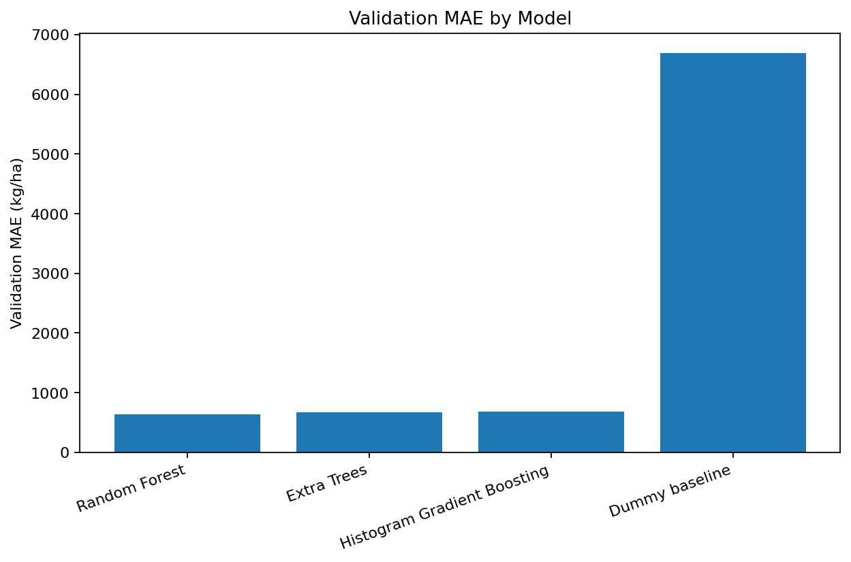

6. Test-Set Visual Analysis
The actual-versus-predicted plot shows how closely the forecasts match observed yield (kg/ha). Residual analysis helps identify systematic underprediction, overprediction, and unusually large errors.
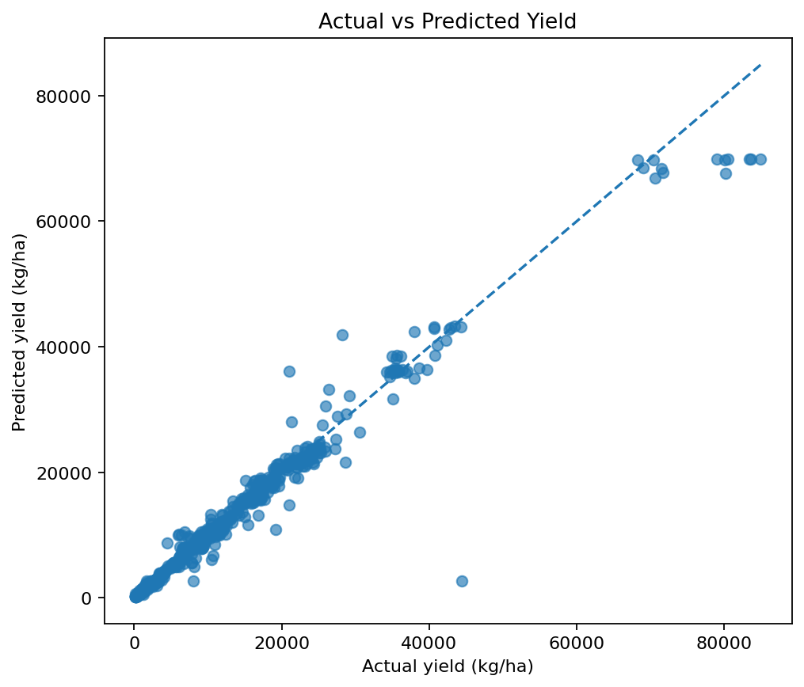
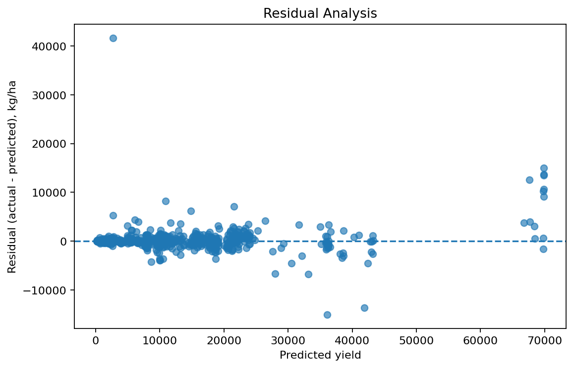
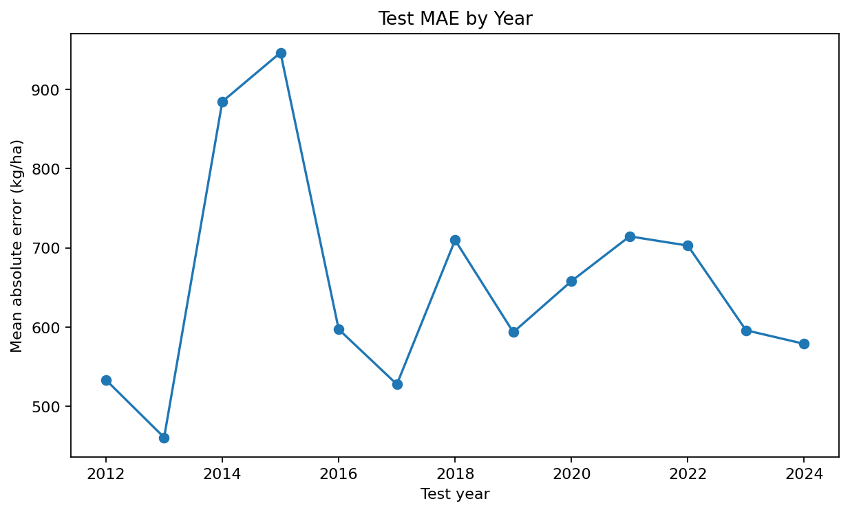
The test set has one area only: India. For that reason, the area-wise table is a national-level result; it cannot show how accuracy differs between states or districts.

7. Crop-wise and Area-wise Findings
Grouped error analysis is included to identify where model performance may be weaker. Groups with small test sample counts should be interpreted cautiously.

Crop-wise error (first 10 rows)
crop | Test_Records | MAE | Mean_Actual_Yield | Mean_Predicted_Yield
Sugar cane | 13 | 7553.192 | 76375.269 | 69065.818
Yams | 11 | 6988.597 | 26960.591 | 25042.868
Cassava, fresh | 13 | 3831.978 | 31695.392 | 32547.655
Strawberries | 10 | 2067.858 | 7154.63 | 7304.527
Oranges | 13 | 1784.045 | 15289.262 | 14774.97
Watermelons | 13 | 1618.059 | 25616.669 | 24966.476
Grapes | 13 | 1576.204 | 21271.823 | 20019.711
Papayas | 13 | 1535.449 | 40253.469 | 40966.802
Apples | 13 | 1299.174 | 7853.2 | 8630.206
Carrots and turnips | 13 | 1242.036 | 17607.231 | 17604.93

Area-wise error (first 10 rows)
area | Test_Records | MAE
India | 1079 | 654.585

8. Baseline Comparison
The selected model's validation MAE was 638.196, compared with 6,689.201 for the median baseline. This represents a 90.46% change in validation MAE relative to the baseline. A positive improvement indicates lower error than the baseline.

Interpretation of the errors
The RMSE (1,991.754 kg/ha) is much higher than the MAE (654.585 kg/ha). This indicates that a smaller number of test predictions have substantially larger errors. The residual plot includes an unusually large positive residual, meaning the model strongly underestimated at least one observation. These records should be checked against the original FAOSTAT values and crop context rather than removed automatically.

9. Limitations
- Historical yield records may be incomplete or inconsistent across crops, areas, and years.
- The current feature set mainly uses historical yield and does not directly include weather, soil, irrigation, or input-use information.
- Extreme weather, pests, policy changes, and other shocks may not be represented in historical predictors.
- A chronological test period from one dataset may not represent every future season or geography.
- MAPE can be unstable when actual values are close to zero.
- Aggregating records by crop, area, and year can hide local variation.

10. Recommendations for Improvement
- Add reliable rainfall, temperature, soil, irrigation, and fertilizer-use features.
- Validate the model on additional regions and later seasons.
- Compare against crop-specific and area-specific baselines.
- Investigate large residuals using source flags and domain knowledge.
- Report sample counts with crop-wise and area-wise performance.
- Monitor performance as new official data becomes available.
- Use forecasts alongside agronomist judgement rather than as an independent decision rule.

11. Stakeholder Reporting Plan
Senior management should receive a concise executive summary with test metrics, business implications, and key risks. Agronomists should receive crop- and area-wise error analysis. Procurement and operations teams should receive clearly labelled forecast information with limitations and human-review guidance. Technical teams should retain the detailed methodology, split periods, and reproducible metrics.

12. Conclusion
This evaluation selected Random Forest using validation MAE and assessed it on a separate chronological test period. The results provide an evidence-based view of historical forecasting performance. Before operational use, the model should be validated across more seasons and regions, enriched with relevant agricultural predictors, and monitored for changes in data quality and prediction error.

